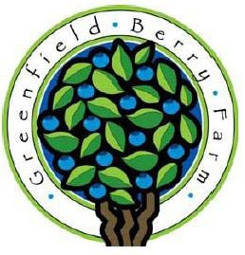
What is a CSA?
Greenfield Berry Farm 2026 CSA

Community Supported Agriculture (CSA) programs unite farmers and families around fresh local food. Farmers grow a variety of vegetables in a natural, sustainable way and pick them at the peak of
flavor and nutrition. The community supports their local farmers by purchasing shares of the harvest and picking them up each week during
the growing season. Together the farmers and CSA
members share in the rewards and risks of farming.

What is unique about this CSA?

Located in the beautiful Cuyahoga Valley National Park, the Greenfield Berry Farm aims to provide fresh, local, and naturally grown produce to our CSA members. Unlike a traditional single-farm CSA, we can provide consistent quality, quantity, and a wider variety of produce by working with other local farmers who share our passion for small-scale farming. Most of the produce will be from our farm, but we can get items from other local farms when we have a slow week or when they have something special that we don’t. Summer CSA members also receive a $20 credit for pick-your-own berries from our farm while half-share members receive a $10 credit.

What types of shares are available?
• Spring share (4 weeks; Friday pickup on 5/15, 5/22, 5/29, and 6/5)
• Summer share (15 weeks; Friday pickup on 6/12, 6/19, 6/26, 7/3, 7/24,
7/31, 8/7, 8/14, 8/21, 8/28, 9/4, 9/11, 9/18, 9/25, and 10/2)
There are no pickups on 7/10 and 7/17.
• Fall share (4 weeks; Friday pickup on 10/9, 10/16, 10/23, and 10/30)
• Half share (11 weeks; every other week starting in May; exact dates to be determined closer to the start of the season)
Note: These dates reflect the likely schedule but could change based on growing conditions.

What can I expect in my share?

Each week you can expect to receive a variety of fresh local vegetables, which will vary with the season. Part of the fun of belonging to a CSA is in learning how the tapestry of produce changes with the time of year and local conditions. Our goal is to provide enough produce for a family of four each week to the best of our ability.

When and where do I pick up my share?

You will pick up your share on Fridays between 5 and 7 pm at the farm (2485 Major Road, Peninsula).

Greenfield Berry Farm
2485 Major Road Peninsula, Ohio 44264 www.greenfieldberryfarm.com

Shareholder Information/Agreement Form

I understand and agree to the terms of the Greenfield Berry Farm CSA and am making a commitment to the 2026 growing season.

I recognize that there is no guarantee on the amount of produce in a week's share.

I understand that I am responsible for cleaning and proper handling after pickup.

I understand and agree to pick up my share on the
specified day and during scheduled hours. (If you are
unable to pick up your share, we can hold it for one day.
Otherwise, please make arrangements to have a friend or neighbor pick it up for you.)

Finally, I understand that farming comes with many risks, such as drought, floods, insect damage, etc. I am willing to share in both the risks and rewards along with the farmers and other CSA members.

Name

Phone

Email

Please check all that apply:

Spring share (4 weeks) - $150

Summer share (15 weeks for returning members) - $510

Summer share (15 weeks for new members) - $535

Fall share (4 weeks) - $150
Half share (11 weeks; every other week) - $400

Total: $

Signature
Date

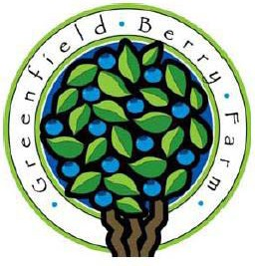
Please send a $100 deposit to secure your CSA share.
Greenfield Berry Farm 2026 CSA

Full payment is due by May 1 for spring shares and half shares, June 1 for summer shares, and October 1 for fall shares.

Please sign and return to:
Greenfield Berry Farm 2485 Major Road Peninsula, Ohio 44264

